Tyson Duran

ECE 2310.03

Project 1

**Guess A Number**

Restart and Clear

Re-Enter

If input is correct, display count and write “Correct. Would you like to play again?”

“y”

“n”

Close Program

Correct

Too High

Too Low

Valid int

Invalid int

If the user is types “y” for new game, restart the program. If they type “n”, close the program.

If valid integer, decide if the integer is correct, less than, or greater than. Add count++

If user types invalid integer, < 1, or > 100, then ask user to re-enter.

If less than random number, write “Too low, re-try.”

If greater than random number, write “Too high, try again.”

Console asks the user io input an integer between 1-100.

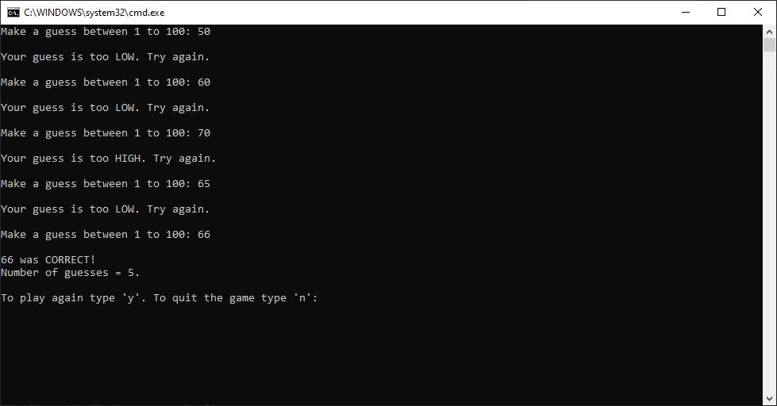

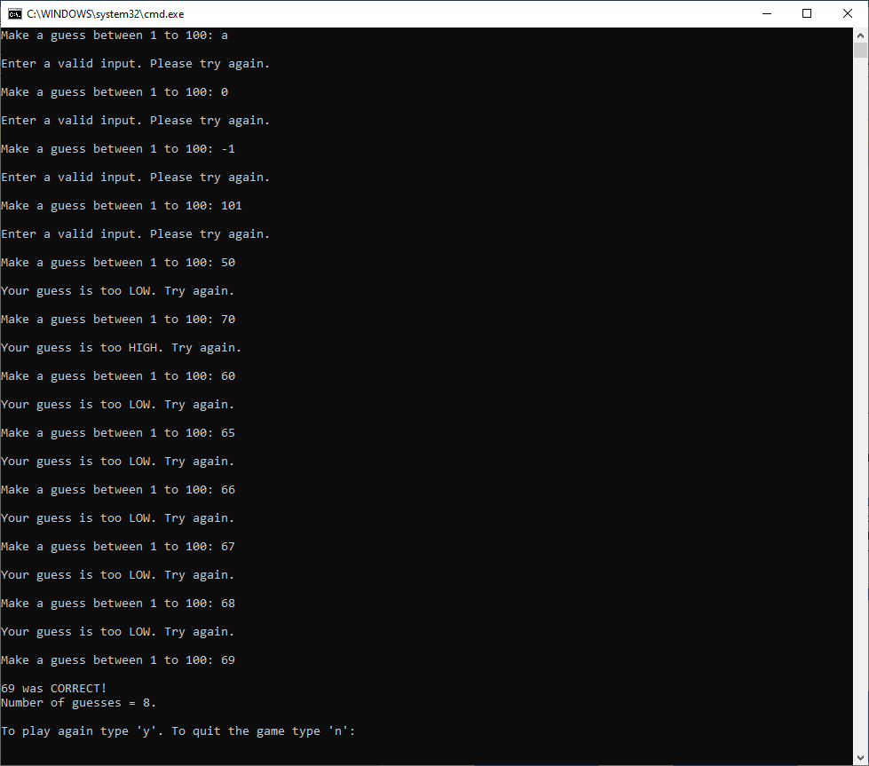

static void Main(string[] args)

{

Random random = new Random();

bool gameStatus = false;

while (gameStatus == false)

{

int correctNumber = random.Next(1, 101);

int userInput = 0;

int count = 1;

while (userInput != correctNumber)

{

Console.Write("Make a guess between 1 to 100: ");

string user_Input = Console.ReadLine();

bool valid = Int32.TryParse(user_Input, out userInput);

if (!valid || (userInput <1) || (userInput > 100))

{

Console.WriteLine("\nEnter a valid input. Please try again.\n");

}

else

{

if (userInput == correctNumber)

{

Console.WriteLine("\n{0} was CORRECT!", correctNumber);

Console.WriteLine("Number of guesses = {0}.", count);

Console.Write("\nTo play again type 'y'. To quit the game type 'n': ");

string res = Console.ReadLine();

char restart;

bool valid2 = char.TryParse(res, out restart);

if (valid2)

{

if (restart == 'n')

{

gameStatus = true;

Console.WriteLine("Thank you for playing!\n");

}

}

}

if (userInput < correctNumber)

{

Console.WriteLine("\nYour guess is too LOW. Try again.\n");

}

if (userInput > correctNumber)

{

Console.WriteLine("\nYour guess is too HIGH. Try again.\n");

}

++count;

}

}

Console.Clear();

}